Experiment-1

Program

@relation exp1

@attribute customerid numeric

@attribute gender{male,female}

@attribute age numeric

@attribute annual_income numeric

@attribute spending_score numeric

@data

1,male,19,15,39

2,male,21,15,81

3,female,20,16,6

4,female,23,16,77

5,female,31,17,40

Output

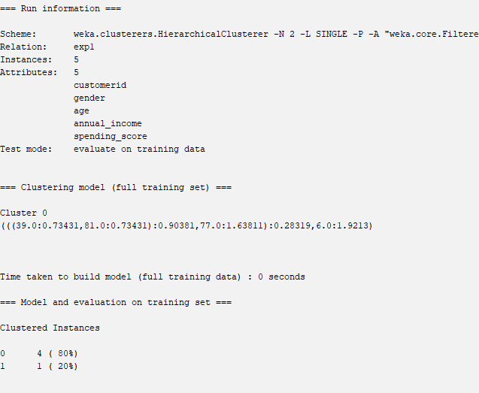

Experiment-2

Program

@relation exp1

@attribute emp_id numeric

@attribute gender{male,female}

@attribute age numeric

@attribute salary numeric

@attribute credit numeric

@data

111,male,28,1500000,39

222,male,25,1500000,27

333,female,26,1600000,42

444,female,25,1600000,40

555,female,30,1700000,64

666,male,29,2000000,72

Output

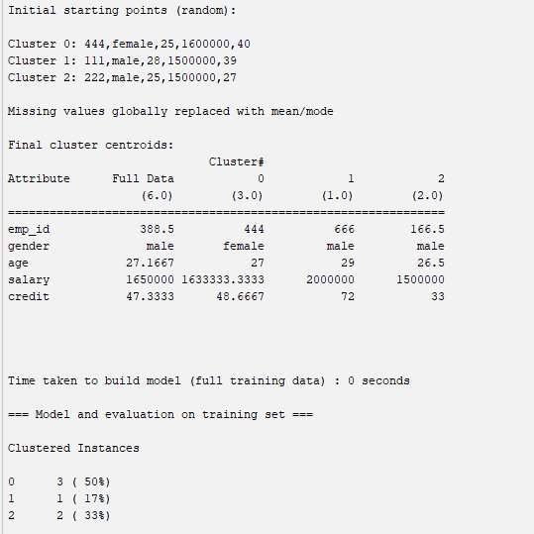

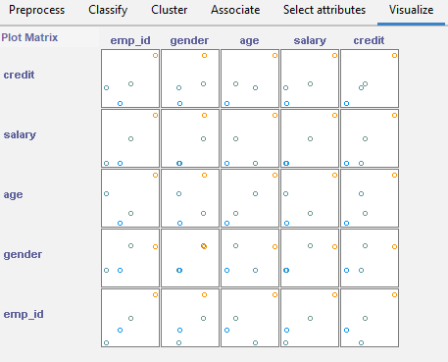

Experiment-3 naivebayes in breast_cancer

Output

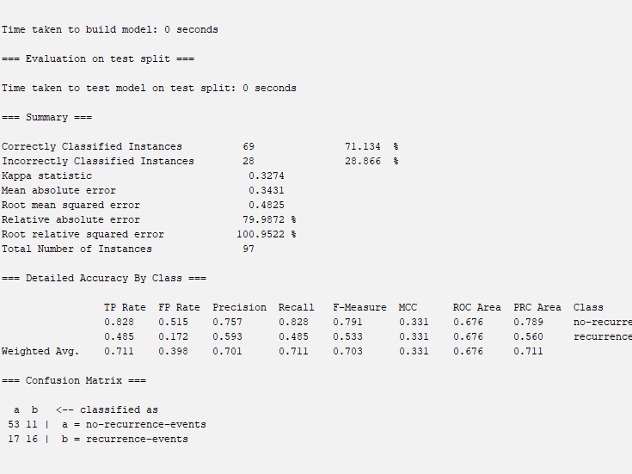

Experiment-4

Program

@relation exp1

@attribute person{gopu,babu,baby,gopal,krishna,jai,dev,malini,hema,anu}

@attribute gender{yes,no}

@data

gopu,yes

babu,yes

baby,yes

gopal,no

krishna,yes

jai,no

dev,no

malini,yes

hema,yes

anu,yes

output;

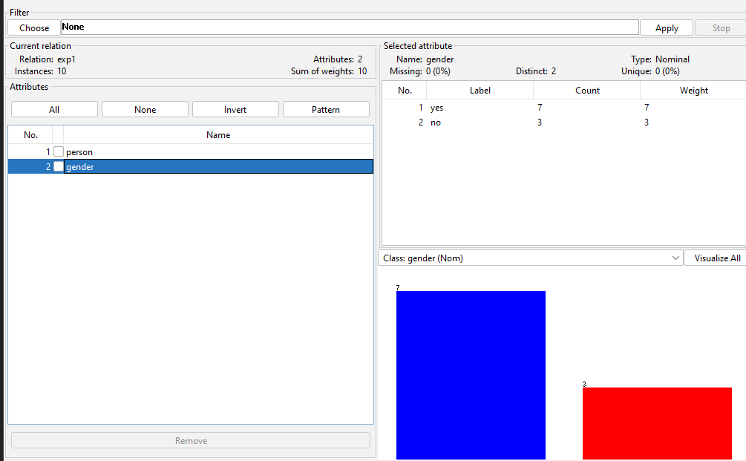

Experiment-6

Program

@relation exp1

@attribute bread{true,false}

@attribute cheese{true,false}

@attribute egg{true,false}

@attribute juice{true,false}

@attribute milk{true,false}

@attribute yogurt{true,false}

@data

true,true,true,true,false,false

true,true,false,true,false,false

true,false,false,false,true,true

true,false,false,true,true,false

false,true,false,true,true,false

output;

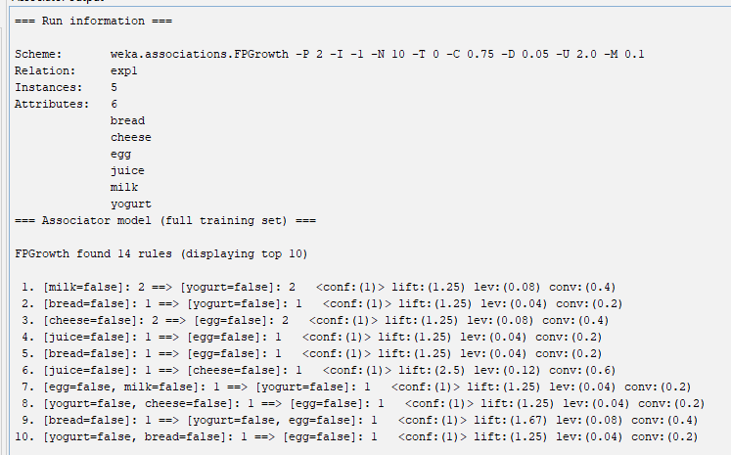

Experiment-7

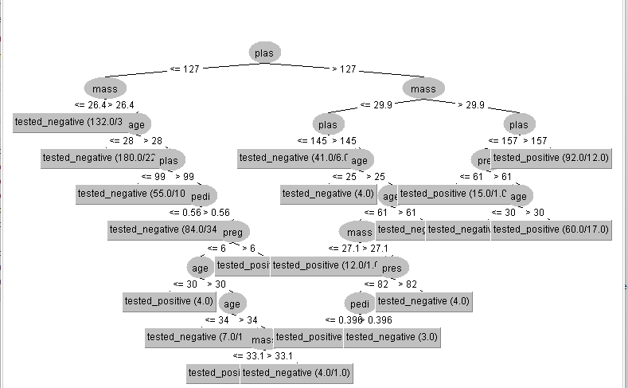

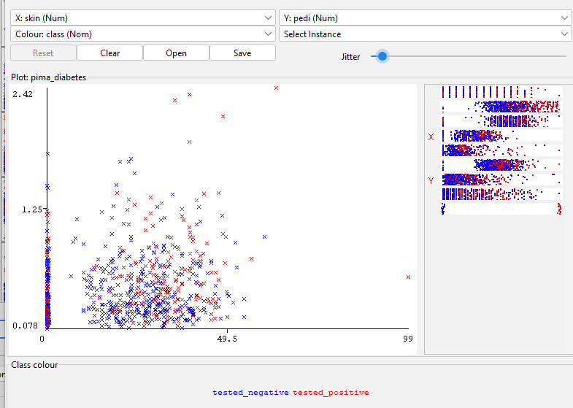

Experiment-8

library(dplyr)

library(tibble)

library(ggplot2)

data <- c(55, 60, 71, 63, 55, 65, 50, 55,58,59,61,63,65,67,71,72,75)

equi_depth <- quantile(data, probs = c(0, 1/3, 2/3, 1))

equi_depth_partitioned <- cut(data, breaks = equi_depth, labels = c("Low", "Medium", "High"), include.lowest = TRUE)

min_value <- min(data)

max_value <- max(data)

width <- (max_value - min_value)/3

equal_width <- seq(min_value, max_value, by = width)

equal_width_partitioned <- cut(data, breaks = equal_width, labels = c("Low", "Medium", "High"), include.lowest = TRUE)

kmeans_model <- kmeans(data, centers = 3)

cluster_assignments <- as.factor(kmeans_model$cluster)

levels(cluster_assignments) <- c("Low", "Medium", "High")

data_tibble <- tibble(data = data, equi_depth_partitioned = equi_depth_partitioned, equal_width_partitioned = equal_width_partitioned, cluster_assignments = cluster_assignments)

ggplot(data_tibble, aes(x = data)) +

geom_histogram(binwidth = 5) +

facet_wrap(~equi_depth_partitioned, ncol = 1, scales = "free_x") +

ggtitle("Histogram using Equi-Depth Partitioning")

ggplot(data_tibble, aes(x = data)) +

geom_histogram(binwidth = 5) +

facet_wrap(~equal_width_partitioned, ncol = 1, scales = "free_x") +

ggtitle("Histogram using Equal-Width Partitioning")

ggplot(data_tibble, aes(x = data)) +

geom_histogram(binwidth = 5) +

facet_wrap(~cluster_assignments, ncol = 1, scales = "free_x") +

experiment-9

program

@relation exp1

@attribute SONY{true,false}

@attribute BPL{true,false}

@attribute LG{true,false}

@attribute SAMSUNG{true,false}

@attribute ONIDA{true,false}

@data

true,true,true,false,false

false,true,false,true,false

false,true,false,false,true

true,true,false,true,false

true,false,false,false,true

false,true,false,false,true

true,false,false,false,true

true,true,true,false,true

true,true,false,false,true

output;

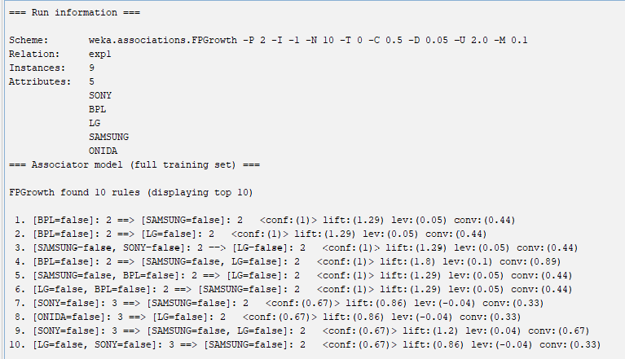

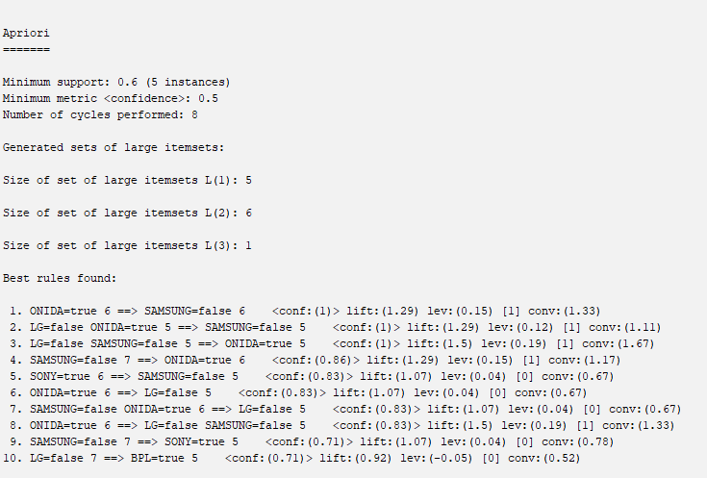

Experiment-10 Program

speed<-c(78,81,82,74,83,82,77,80,70)

time<-c(39,37,36,42,35,36,40,38,46)

a<-var(speed)

b<-var(time)

ss<-sqrt(var(speed))

st<-sqrt(var(time))

a

b

ss

st

output

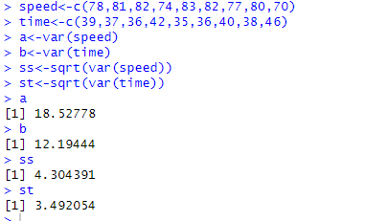

Experiment-11

a<-c(100,70,60,90,90)

min=0

max=1

v<-((a-min(a)/max(a)-min(a))*max+min)/100

summary(v,method=c("range"))

v

#zscore

w=mean(a)

s=sd(a)

z=(a-w)/s

summary(z)

z

output

